Flow Charts
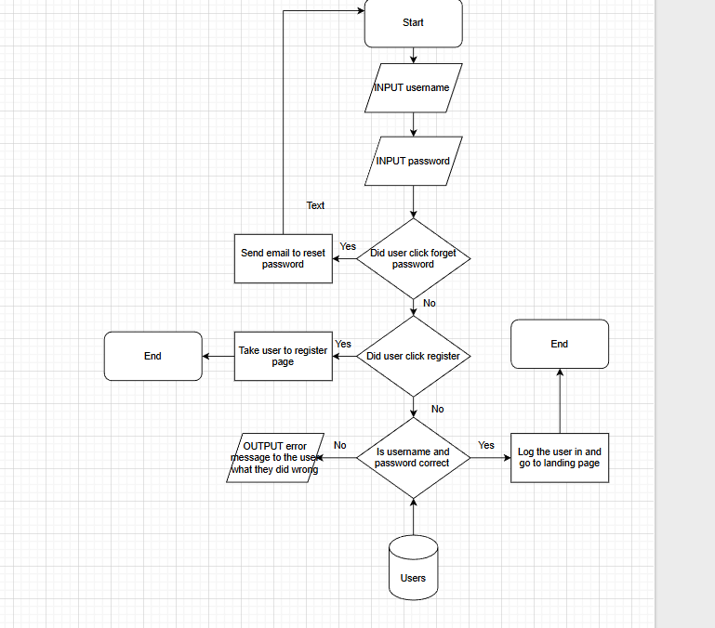Log in:
The user will be prompted to enter their username and password the system will then check if the user clicked other options like forgot password or register if they did it will take the appropriate actions like sending a reset email link or taking the user to the register page if not the system will check if the username and password match the ones in the database of not it will send an error message telling the user what they did wrong if its correct the system will log the user in return them to the landing page.

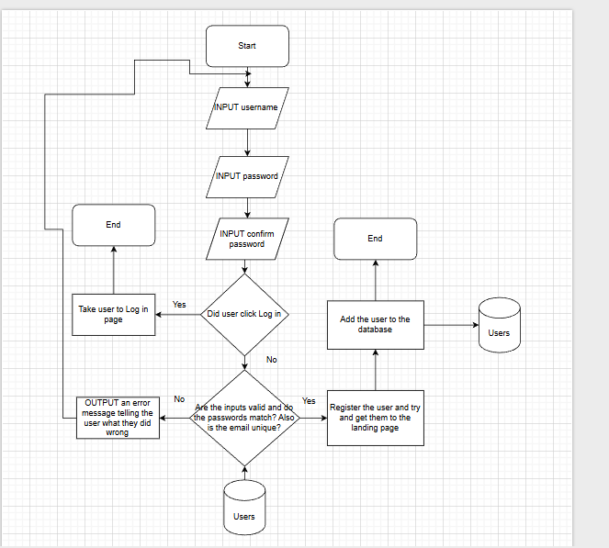 Register:
The user will be prompted to enter their username and password the system will check if the user clicked their options like log in if it did will send the user to the log in page otherwise it will check if the user details are valid, if the passwords match and if the email isn't already registered if all this is correct and it isn't an existing email the system will register the user and send them to the lading page and add there details to the database.

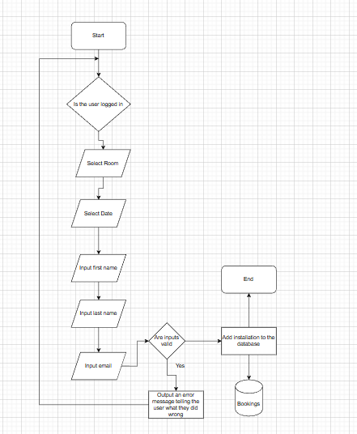
Bookings:
The user will be prompted to enter their username and password the system will then check if the user clicked on log in. If the log in is invalid, the system will redirect the user to the registration page. When the user is logged in, the system will check if the user clicked on Room. Afterwards, the user will be prompted to book a room. The page will show the date for the booking, ask the user for their first name, their last name and to input their email address. If valid, the system will install it into the Booking database. If not valid, the system will output an error message telling the user what they did wrong and to retry.

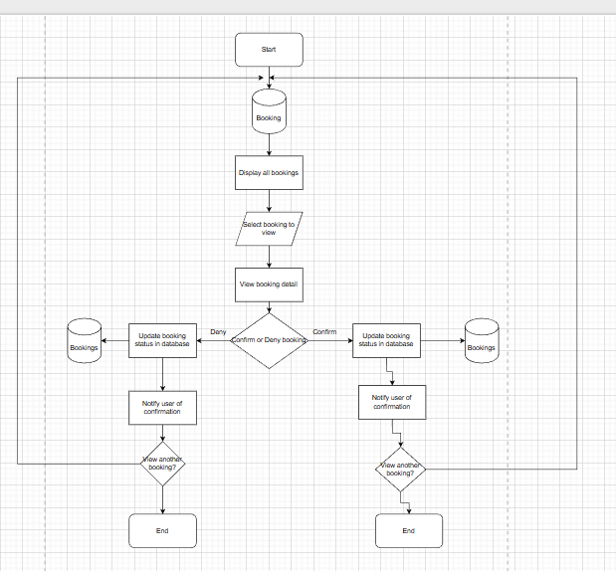Staff confirming or denying bookings:
The system will allow the staff to see all the booking that has been requested on the system. Staff can click onto the booking to be able to view them and have the power to either deny the booking or confirm the booking. If the staff denies the booking, then it will send a notification to the booking database telling the user that their booking has been denied. If the staff confirms the booking, then it will send a notification to the booking database telling the user that their booking has been confirmed.

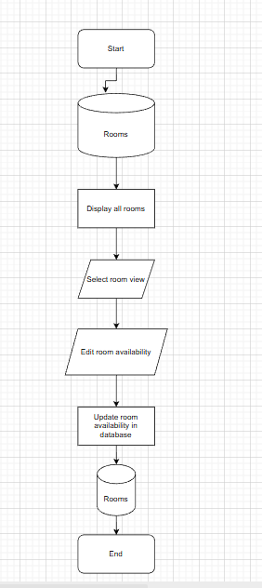
Room availability:
The staff will be able to go into the room database to be able to view all rooms. Then the staff can select the rooms then edit them. They can edit the room availability seeing if it’s available or unavailable. Finally, the staff can update the changes to the Rooms database to notify the user if the room is available or not.

Database Design
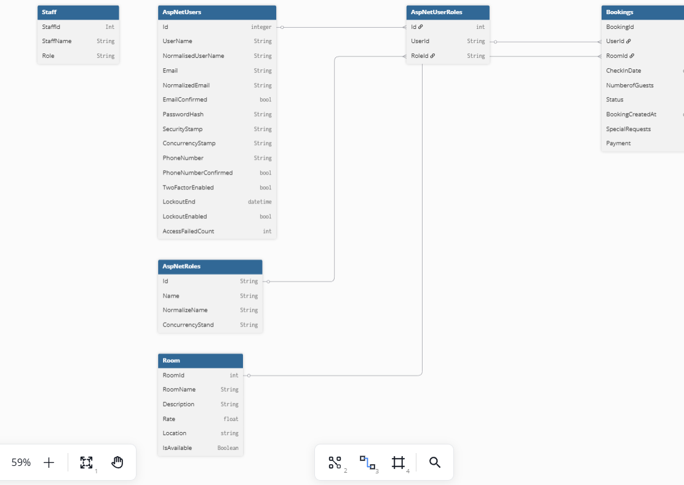

Data Dictionary

AspNetUsers
Collum | Data Type | Required | Default | Validation | Primary/ Foreign
Id | String | Yes |  |  | Primary
UserName | String | Yes
NormalisedUserName | String | Yes
Email | String | Yes |  | Must include a valid structure, must have a “@” symbol, must have a domain name, must be in the correct format.
NormalisedEmail | String | Yes
EmailConfirmed | Bool | Yes |  | Users must confirm their email.
PasswordHash | String | Yes
SecurityStmp | String
PhoneNumber | String
PhoneNumberConfirmed | Bool
TwoFactorEnabled | Bool
LookoutEnd | DateTime
LookoutEnabled | Bool
AccessFailedCount | Int

AspNetUserRoles
Collum | Data Type | Required | Default | Validation | Primary/ Foreign
Id | Int | Yes |  |  | Primary
UserId | String | Yes | Users Id |  | Foreign
RoleId | String | Yes

spNetRoles
Collum | Data Type | Required | Default | Validation | Primary/ Foreign
Id | String | Yes |  |  | Primary
Name | String | Yes
NoralisedName | String | Yes
ConcurrencyStamp | String | Yes

Staff
Collum | Data Type | Required | Default | Validation | Primary/ Foreign
StaffId | Int | Yes |  |  | Primary
StaffName | String | Yes
Role | String | Yes

Room
Collum | Data Type | Required | Default | Validation | Primary/ Foreign
RoomId | Int | Yes |  |  | Primary
RoomName | String | Yes
Description | String | Yes
Rate | Float | Yes
Location | String | Yes
IsAvailable | bool | Yes

Bookings
Collum | Data Type | Required | Default | Validation | Primary/ Foreign
BookingId | Int | Yes |  |  | Primary
UserId | String | Yes |  |  | Foreign
RoomId | String | Yes |  |  | Foreign
CheckInDate | String | Yes
NumberOfGuests | Int | Yes
Status |  | Yes
BookingCreatedAt | String | Yes
SpecialRequests | String | Yes
Payment | Float | Yes

SiteMap
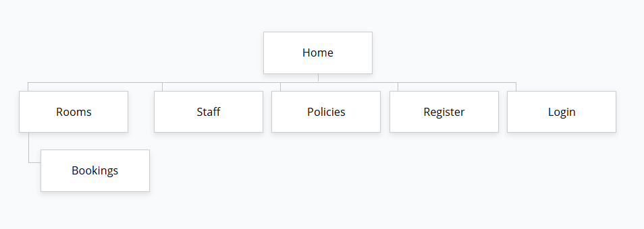

Wire Frame

Login
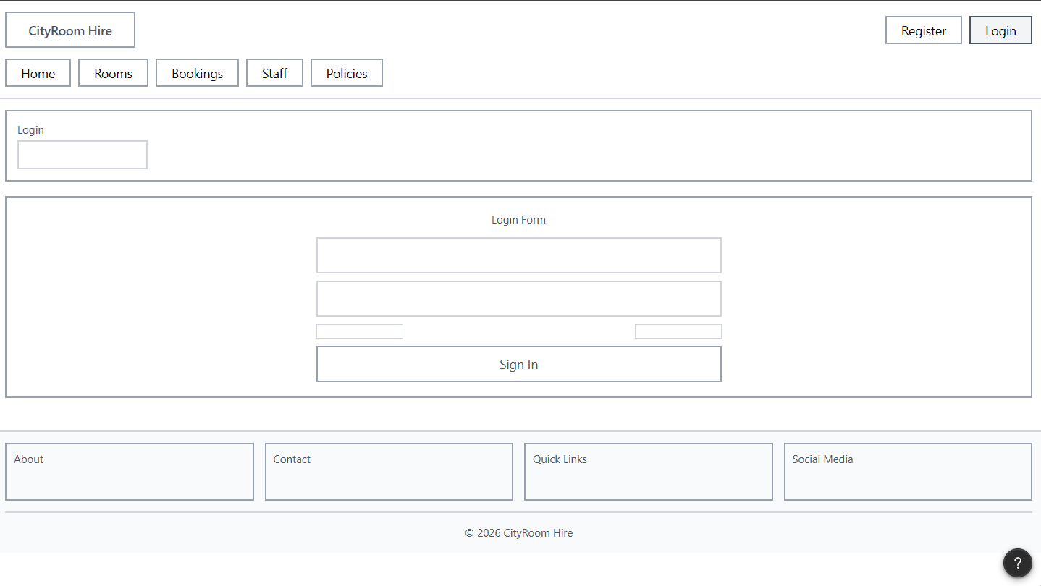
Note:
- Here I clearly stated to the user that they are on the log in page
- Here I added boxes where the user will need to put their email and password. I used a square box since is a common convention and reduces uncertainty for the user when logging in.
- I used black text to ensure readability and a faded grey so the user does not confuse it for an imputed text. For all the text I used open sans t to keep it consistent with the rest of the site
- The box just before the sign in box is a link for “forgot password”. I also made this smaller to utilise visual hierarchy and not take the users attention from the main form. This will allow the user to reset their password improving the sites navigation.
- Here I used a heading called social media, which will enhance credibility and trust and there online following and make them stand out.
- For “Contact” on the footer, it allows the users to easily view the company contact information in an easy to find place. This helps sites follow common conventions as it is industry standard to have contact information in the footer. Furthermore, I used Open Sans for readability.
- Here I added a copyright note as a small reminder to users about the company’s legal rights, reducing the chance of people committing copyright infringement. I have made it smaller so it doesn’t take up too much space and used Open Sans for improved readability. Also, by including this on the footer, the site is following the industry standard.

Register
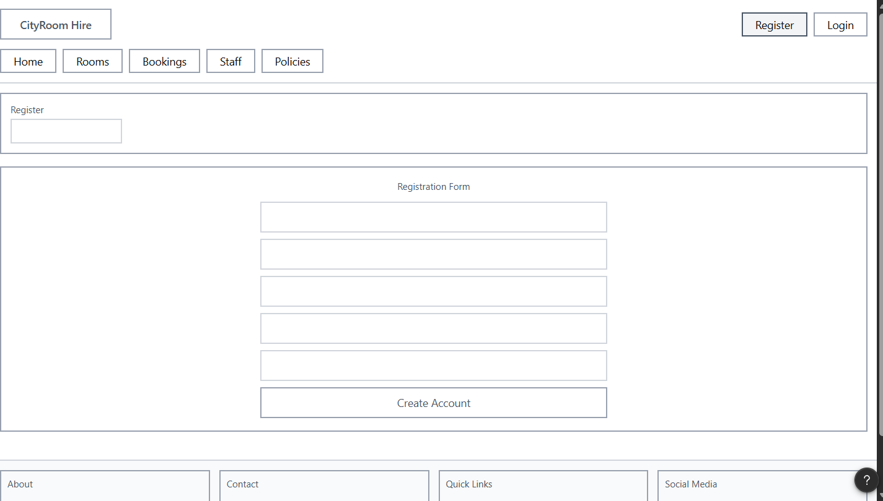
Note:
- Here I clearly stated the user to Register so they know that they are on the resignation page.
- Here I added boxes where they’ll need to input their name, username, email, password and confirm password. I used a square box since is a common convention and reduces uncertainty for the user when they are registering.
- I used black text to ensure readability and a faded grey so the user does not confuse it for an imputed text. For all the text I used open sans t to keep it consistent with the rest of the site
- I added a large box highlighting “Create Account”. This is used for clarity so that the user knows what box to press or click when wanting to make an account.
- Here I used a heading called social media, which will enhance credibility and trust and there online following and make them stand out.
- For “Contact” on the footer, it allows the users to easily view the company contact information in an easy to find place. This helps sites follow common conventions as it is industry standard to have contact information in the footer. Furthermore, I used Open Sans for readability.

Home page
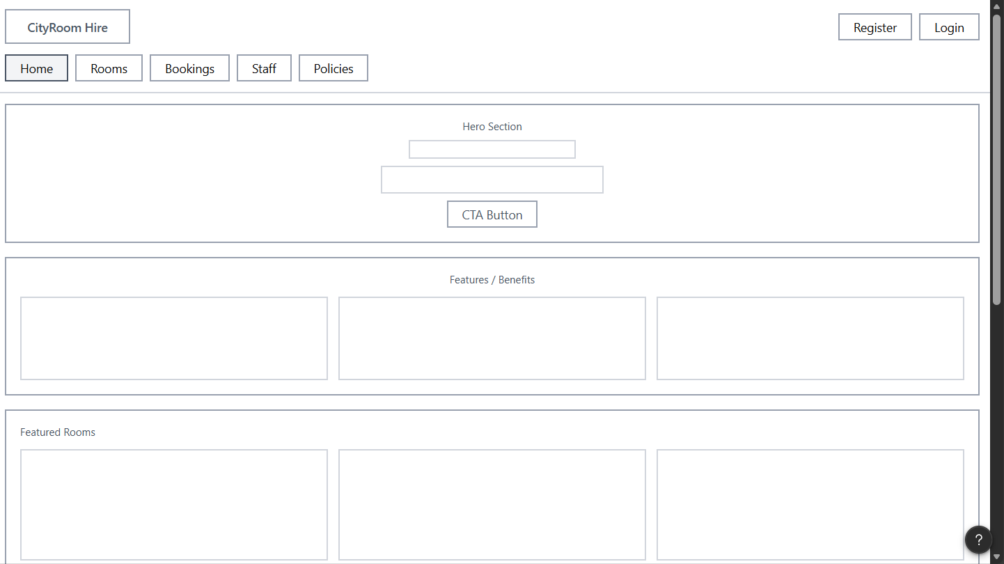
Note:
- I have used Open Sans for my nav bar font as it is clear and easy to read.
- I used the colour black so it’ll stand out, ensuring it follows the WCAG level AAA requirements and is easy to read.
- Finally, I used consistent spacing to make the site easy to navigate with no confusion and ensure it follows industry standards. I have kept this the same throughout the site to make it easy to navigate and consistent, creating a better user experience.
- Below the first big box, I added a heading for this section to inform the user of the features and benefits about the website. I used a bigger text size on open sans to make it easily readable and recognisable as a heading and make it distinguishable as a heading. This helps the heading stand out which follows industry standard procedures.
Rooms
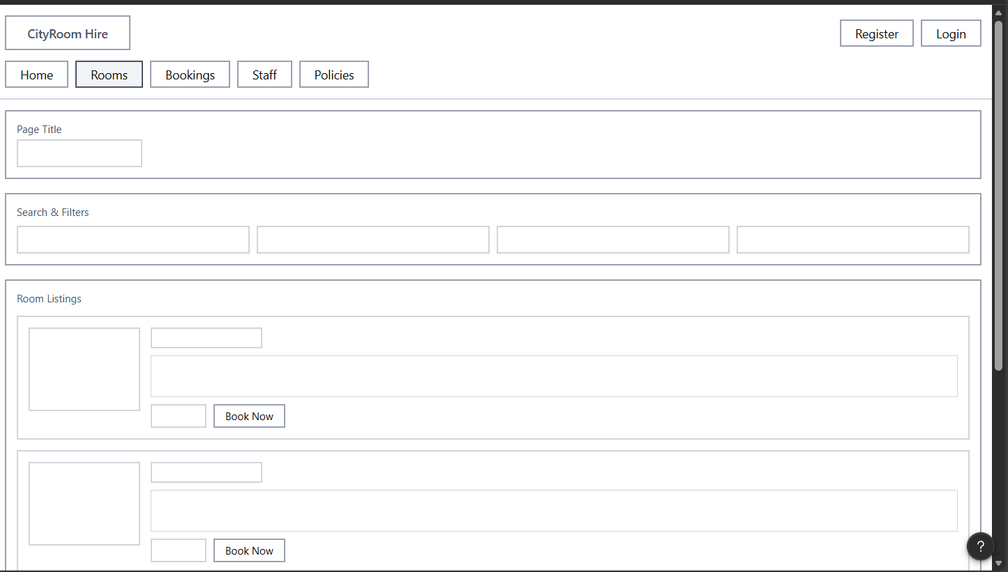
Note:

Bookings

Staff
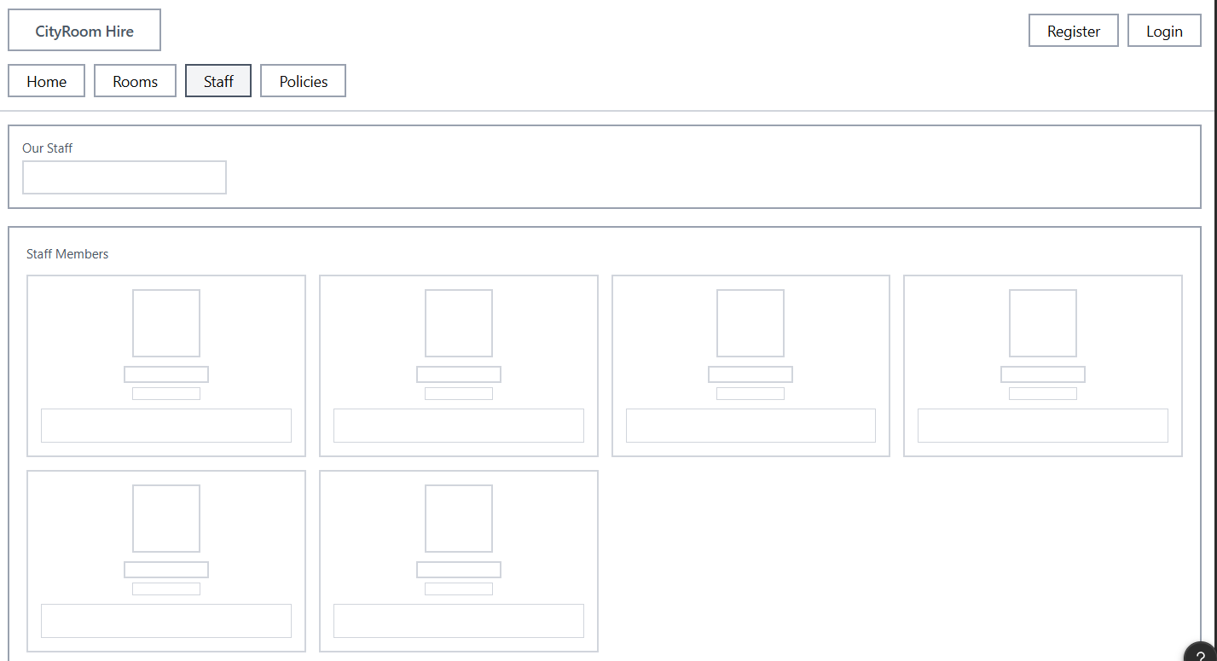

Policies
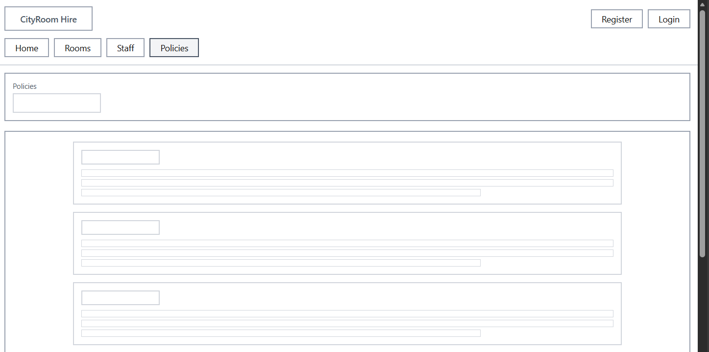

Test Strategy:
Date of Test | Component to be Tested | Type of Test to be Carried out | Prerequisites and dependencies
 | Register | White box  Black box  Functionality  Security  Integration | The register function should be fully functional and implemented. Migrations and update database must be applied. The controller logic should be completed to handle user registration and error handling for incorrect inputs, duplication accounts and password completely must be set up.  TEST DATA:  Normal  Email: test@testemail.com  Password: Password123!  Confirm Password: Password123!  Erroneous  Email: falsemail  Password: 111  Confirm Password: 121  Extreme  Email: test@testemail.com  Password: QwE12?  Confirm Password: QwE12?
 | Log in | White box  Black box  Functionality  Security  Integration | The log-in page must be created. The migration and update database must be completed also. There must be working controller logic.  TEST DATA:  Normal  Email: test@testemail.com  Password: Password123!  Confirm Password: Password123!  Erroneous  Email: falsemail  Password: 111  Confirm Password: 121  Extreme  Email: test@testemail.com  Password: QwE12?  Confirm Password: QwE12?
 | Log out | Black box testing  Functionality  Security  Integration | The log in system must be fully functional and allow users to create accounts and save their data to a database.  The Log out button should be clear and easily visible.  No test data required.
 | Forgot password | Black box testing  Functionality  Security  Integration | The log in system must be fully functional.  A valid account must exist within the database.  Forgotten system must also be fully functional.  The tester should click forgot password, and a reset email should be sent to reset the password. No test data needed
 | Remember me check box on the log in page | Black box testing  Functionality  Security  Integration | The log in system must be fully functional.  A valid account should exist within the database.  The tester must click the remember me check box when logging in, leave the page and then open the page again on the same devices to check if the webpage kept the user logged in.  No test data needed.
 | Accessibility features | Black box  Functionality  Integration | Accessibility system must be fully functional and accessible by users.  Tester should test each accessibility feature to see if it works. For example, colour mode, text resize and text-to-speech.  No test data needed.
 | Link buttons on the navigation bar | Black box  Functionality  Integration | All the pages for each link should be made and the controller logic for each link must work correctly.  The navigation bar should be made and be fully functional.  Tester must check each link to see if it leads to the correct page.  No test data needed.
 | Rooms section | White box  Black box  Functionality  Integration | The home page should be made and fully functional.  The rooms page should also be made and fully functional.  The tester must be able to view all the existing rooms.  No test data needed.
 | Bookings section | White box  Black box  Functionality  Integration | The home page should be made and fully functional.  The booking page should also be made and fully functional.  The tester must be able to view all existing bookings.  No test data needed.
 | Staff section | White box  Black box  Functionality  Integration | The home page should be made and fully functional.  The staff page should also be made and fully functional.  The tester must be able to view all existing staff.  No test data needed.
 | Policies section | White box  Black box  Functionality  Integration | The home page should be made and fully functional.  The policies page should also be made and fully functional.  The tester must be able to view all existing policies.  No test data needed.
 | Links on the footer | Black box  Functionality  Integration | All the pages for each link should be made and the controller logic for each link must work correctly.  The footer should be made and be fully functional.  Tester must check each link to see if it leads to the correct page.  No test data needed.
 | Staff confirming or denying booking
 | Room availability
 | Filter rooms
 | Booking a room
 | Details on the book now page
 | Review previous booking

